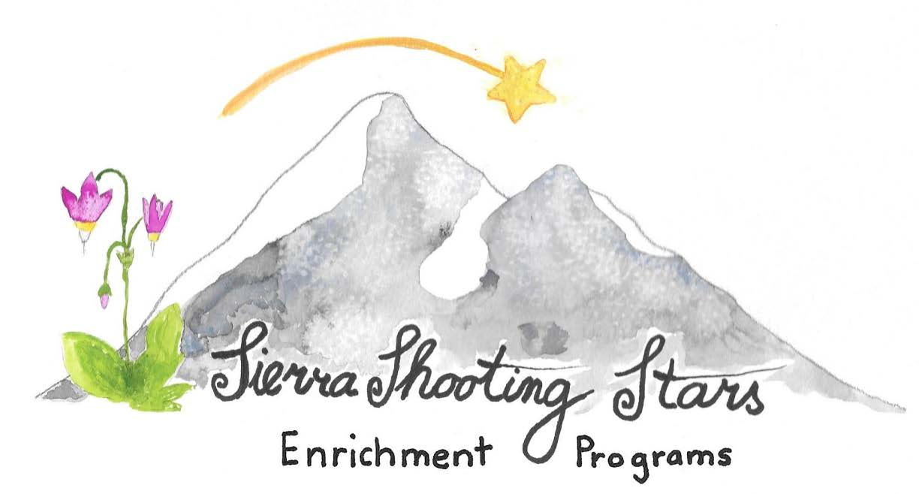

Adolescent Guide Positions

Sierra Shooting Stars Enrichment Programs is a Home School Co-Op in Reno, Nevada.

We currently have an Elementary Montessori Mentor and we are looking to expand our program to have an Adolescent Program for students aged 14-15 (9th & 10th grade).

We are looking for three Montessori Adolescent Guides who can teach either Humanities, Math, or Engineering/Physics, along with one other subject.

We are seeking enthusiastic, collaborative professionals with strong interpersonal skills to be High School School Mentors. You can authentically join students along their journey as you guide them towards discovery! Join a small adolescent program focused on hands-on, experiential learning. Co-teach a small group of motivated 9th and 10th grade students, while supporting both group and individualistic programs.

Qualifications:

• Bachelor’s degree in related subject

• Montessori Credential for adolescents, preferred but not required

• Minimum of three years’ experience teaching and working with adolescents

• Excellent verbal and written skills with students, colleagues and parents

• Demonstrated strong organizational and planning skills

• Understanding of, or interest in, Montessori methods and pedagogy

• Ability to pass criminal background check

Compensation: DOE (depends on experience)

Qualified candidates should email resume and cover letter to: sierrashootingstarsenrichmentprograms@proton.me